**TBI GEU**

**SDE ASSISTANT INTERN**

**Vishwas Malik**

**Month 2**

**https://github.com/malik-vishu/TBI/tree/main/Month2**

**Topics covered:**

* **Git**
* **TypeScript**
* **SDLC**
* **AWS**
* **React**
* **MERN**

**Week 5**

* **Git's key concepts, commands**
* **Implement basic version control for a project**
* **TypeScript's key features, syntax, and usage**
* **Code Migration JavaScript to TypeScript**

**Week 6**

* **Agile and Scrum concepts learned**
* **Explored AWS Services**

**Week 7**

* **Fundamental concepts of React**
* **Simple React application**
* **Experience with LeetCode**
* **Web application that integrates a frontend (using React) with a backend (using Node.js/Express)**
* **Detailing the phases of SDLC**
* **A Todo application using the MERN stack**

Started with the basics of Git and ended month 2 with some understanding of React and MERN.

Topics covered were focused on overall project development.

Main projects:

* TODO app using MERN stack
* Quiz app using React

Total 18 submissions.

**Git concepts**

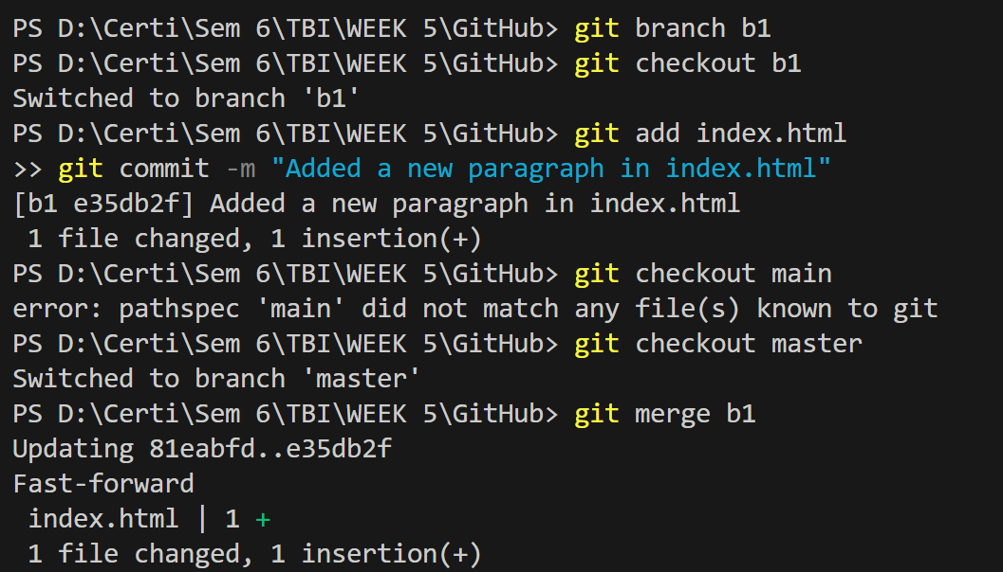

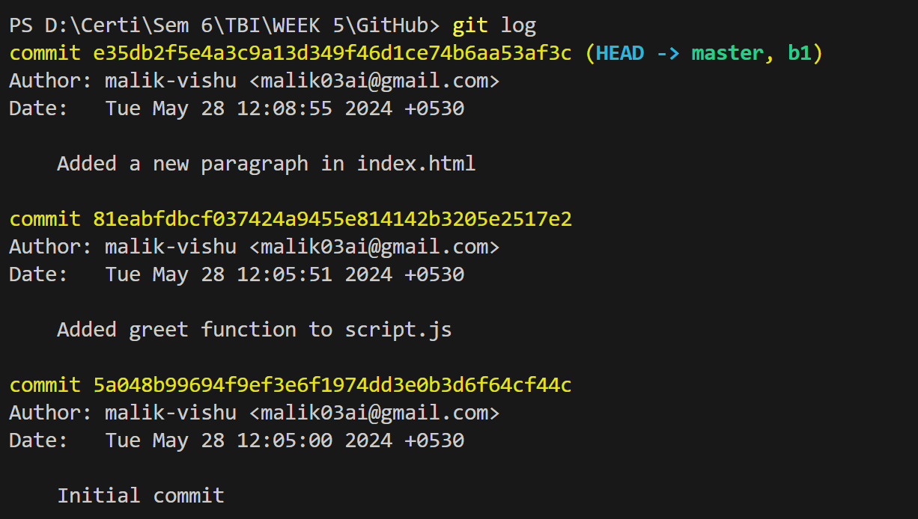

**Agile and Scrum concepts**

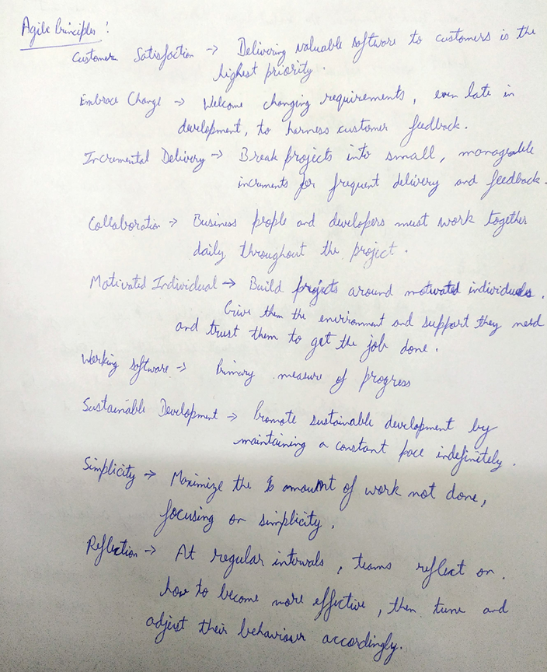

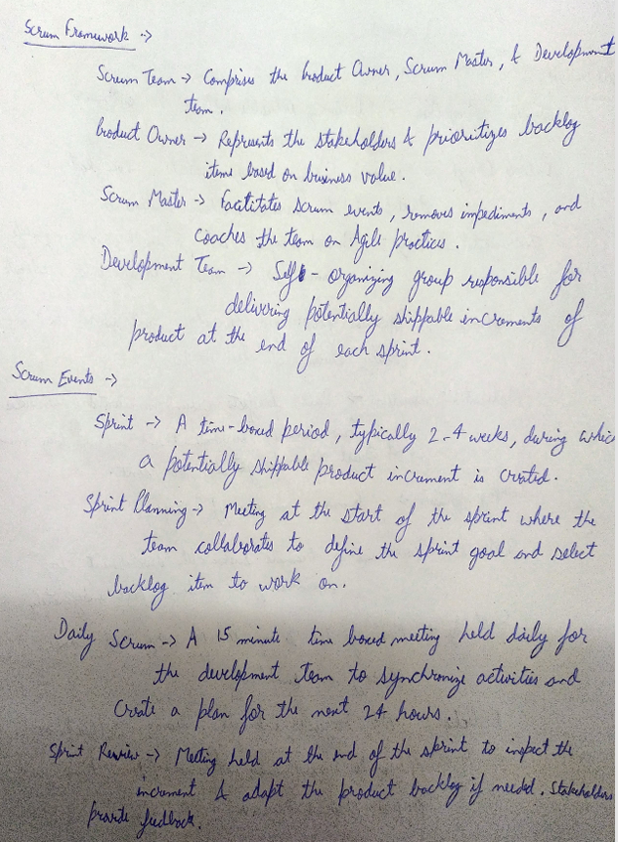

**Quiz App**

**Project Structure**

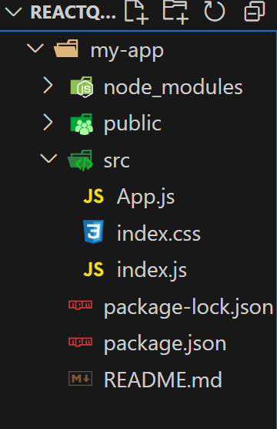

Fig.1

**Question Structure**

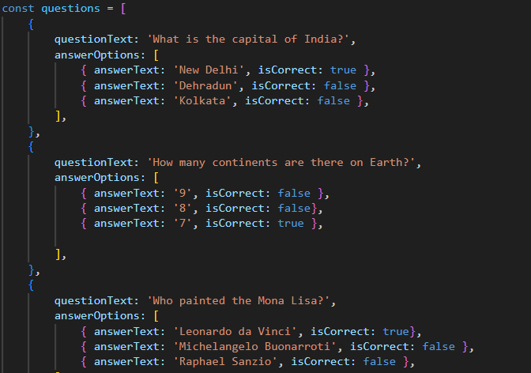

**Result**

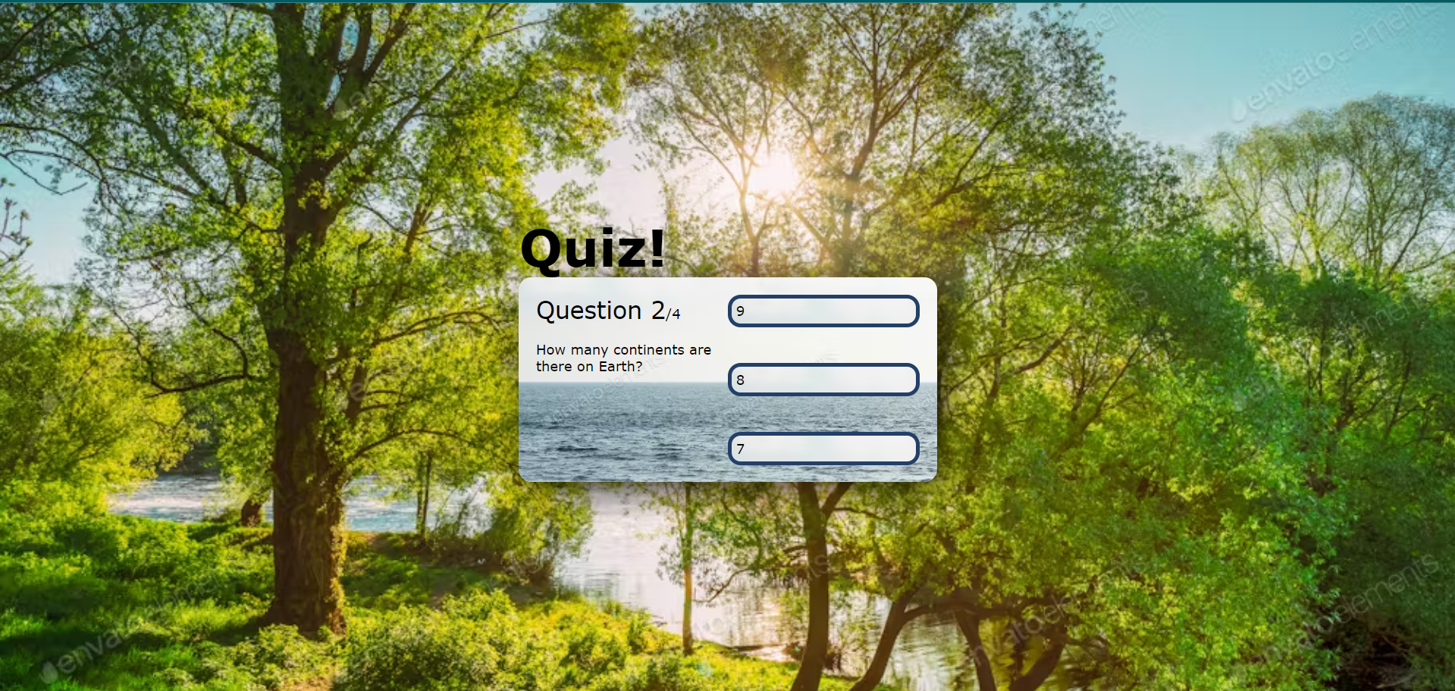

Fig.1

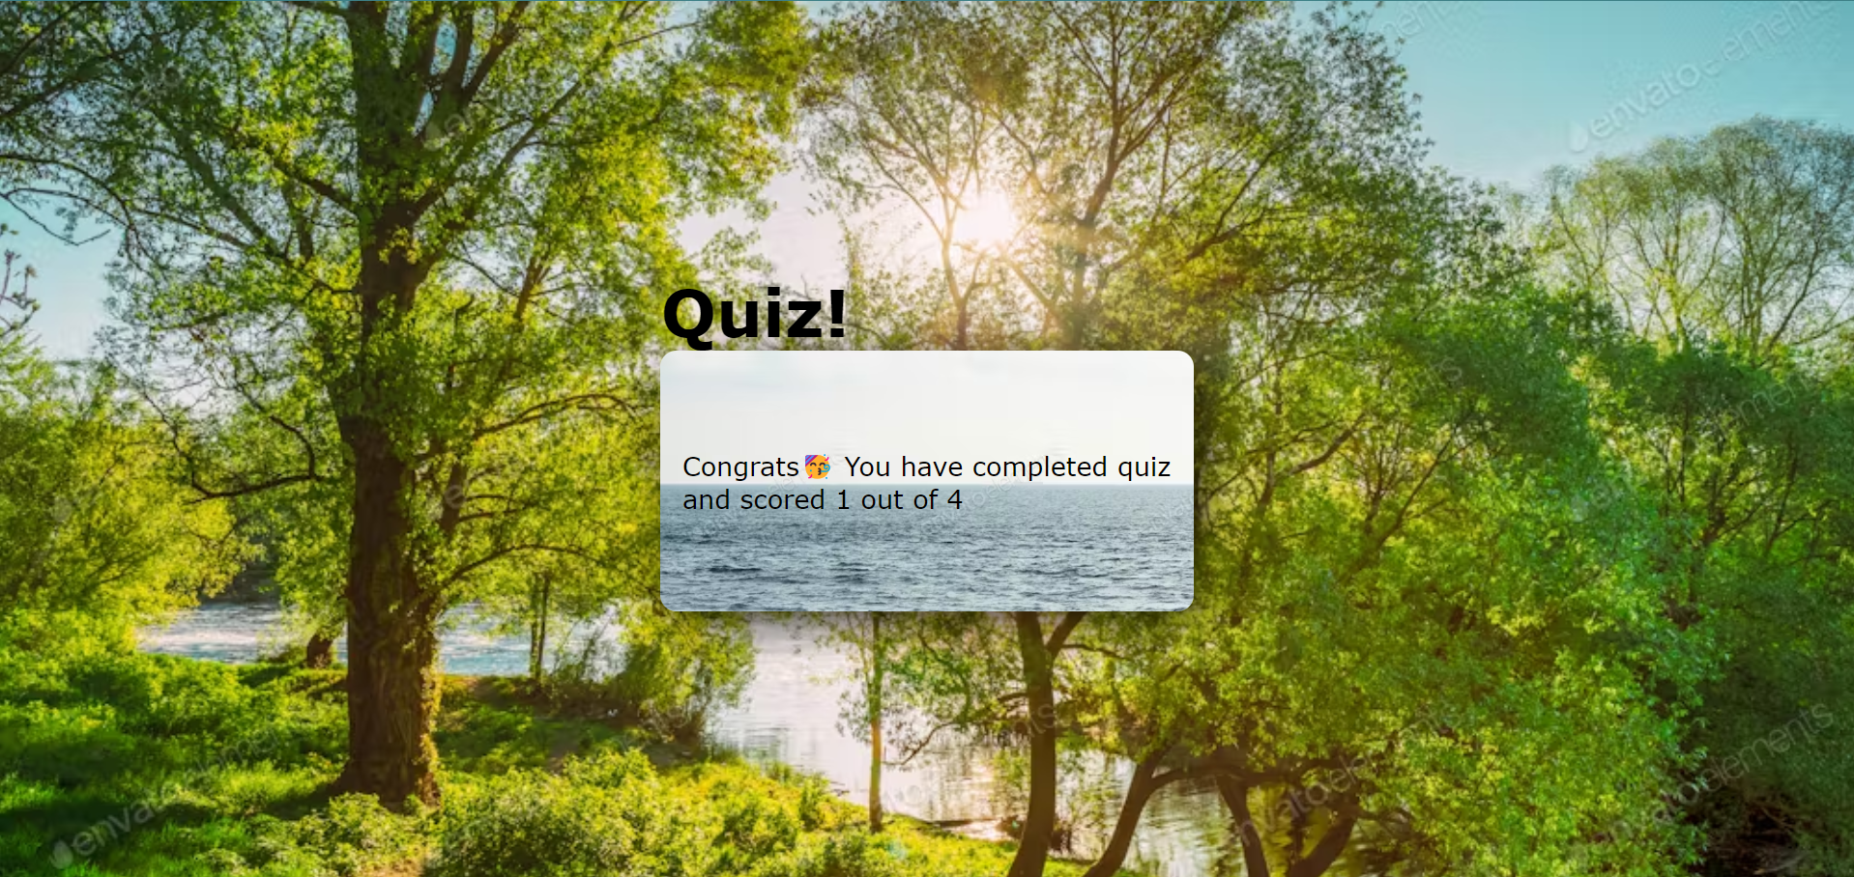

Fig.2

**TODO App**

**Project Structure**

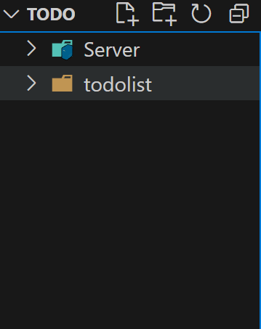

Fig.1

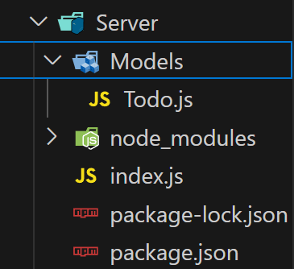

Fig.2

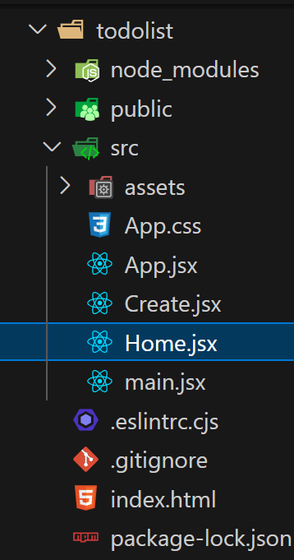

Fig.3

**Server**

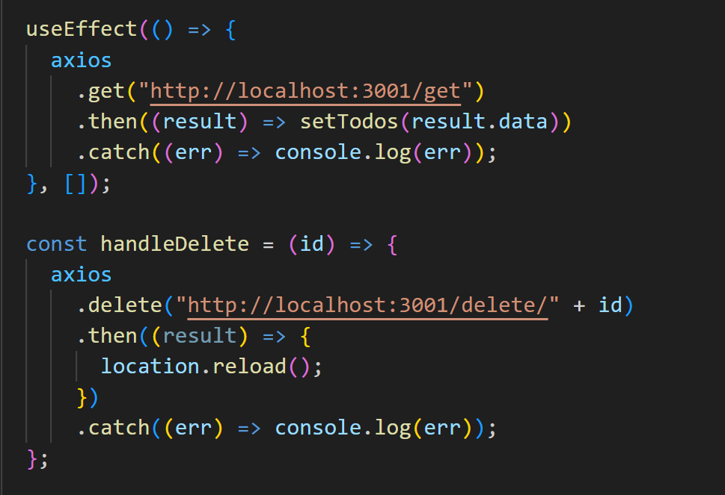

Fig.1 Requests to server

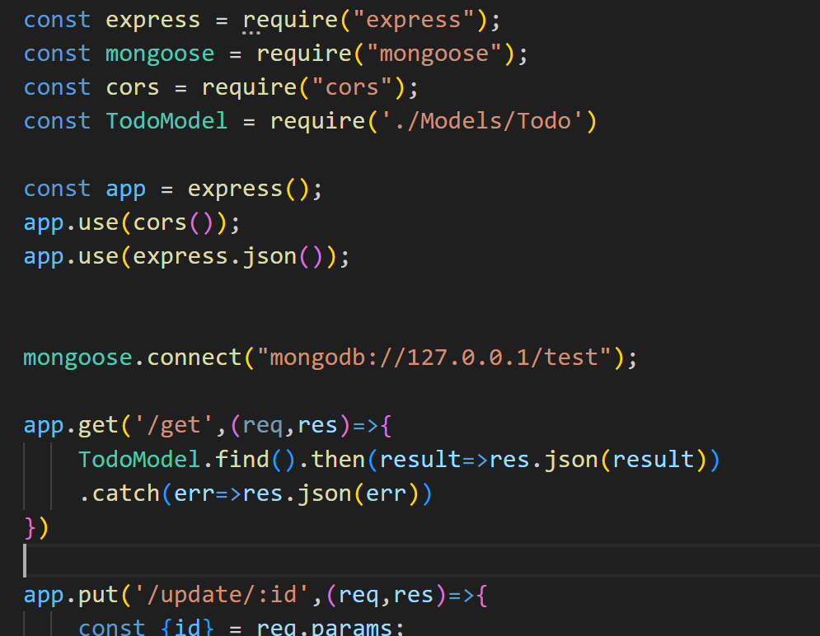

Fig.2 Handling Request

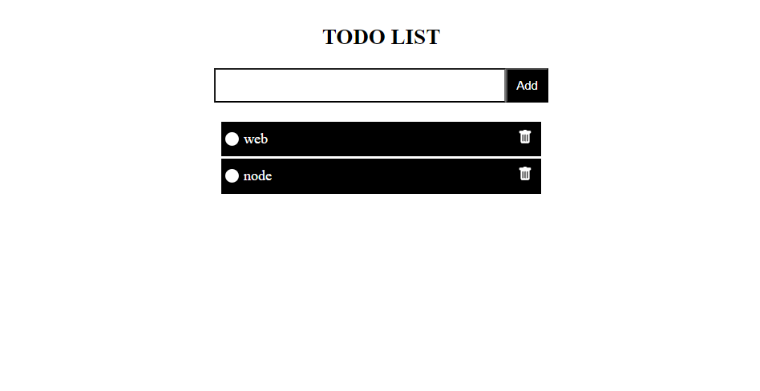

Fig.1 Result